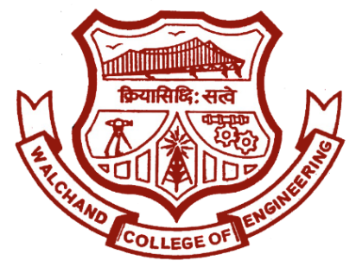

Walchand College of Engineering, Sangli.

(An autonomous institute)

&

Electronics Engineering Students’ Association (ELESA)

Presents

ELECTROVERT 2017

The Performers’ creed

Website: www.elesa.in

Email: [walchand.elesa@gmail.com](mailto:walchand.elesa@gmail.com)

ELECTROVERT 2018

EVENT STRUCTURE

**ELECTROCHAMP**

This is the main attraction of ELECTROVERT. This year ELECTROCHAMP is open to all. This event is specially designed for those candidates who has core knowledge of electronics.It will be a technical event basically based on Ebedded sysytems.The controller which you will be using is 8051.Anyone from any branch can participate in ElectroChamp, if they are confident enough about their embedded knowledge.

**EVENT STRUCTURE:**

* Each team will be consist of 4 members.
* Winner of Circuit Tech, Age of Utron and Proignito will get direct entry to this event and finalist of these events will get 50% off for ElectroChamp.
* The entry fee will be 200/- per group.
* This is a full day event so whoever wants to participate in this event wont be able to participate in any other Day 2 event.